A1: THE ESG ACTIVATION/ENHANCEMENT PLAN FOR MY LEADERSHIP ROLE AT COMPANY X

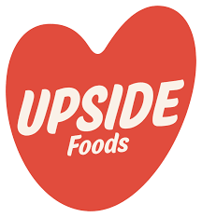

# **MEETING SUSTAINABILITY GOALS**

Arunima Bollampally

Upside Foods, founded in 2015 and based in Berkeley, California, is a pioneer in cultivated meat, focusing on cultivated chicken. Backed by investors like Bill Gates and Tyson Foods, it has raised over $600 million and achieved FDA & USDA approval in 2023. The company has advanced production with 50,000-liter bioreactors and launched them in high-end restaurants like Bar Crenn.

We allocate 1% of revenue to sustainability initiatives and are standardizing SASB/GRI reporting. Guided by CEO Uma Valeti’s vision of safe, sustainable meat, I, as CSO, will develop the ESG activation plan. Our Sustainability Working Group (SWG) includes key executives, frontline managers, and experts, engaging stakeholders like investors, employees, industry, government, NGOs, and clients.

**Long-range Business Plan:** To scale-up cultivated meat production at the California facility from 50,000 to 400,000 lbs while expanding beyond chicken to other meat varieties for a larger, more affordable consumer reach.

**Materiality Assessment:** A materiality assessment was conducted to identify ESG priorities that are most critical to both stakeholders and the company's long-term success, forming the foundation for an effective ESG activation plan. Findings of SWG on Materiality assessment implied six key priorities that are of importance to both shareholders and the company viz and were clubbed as per report priority.

**(Contd..)**

**Fig 1: Materiality Assessment of Upside Foods**

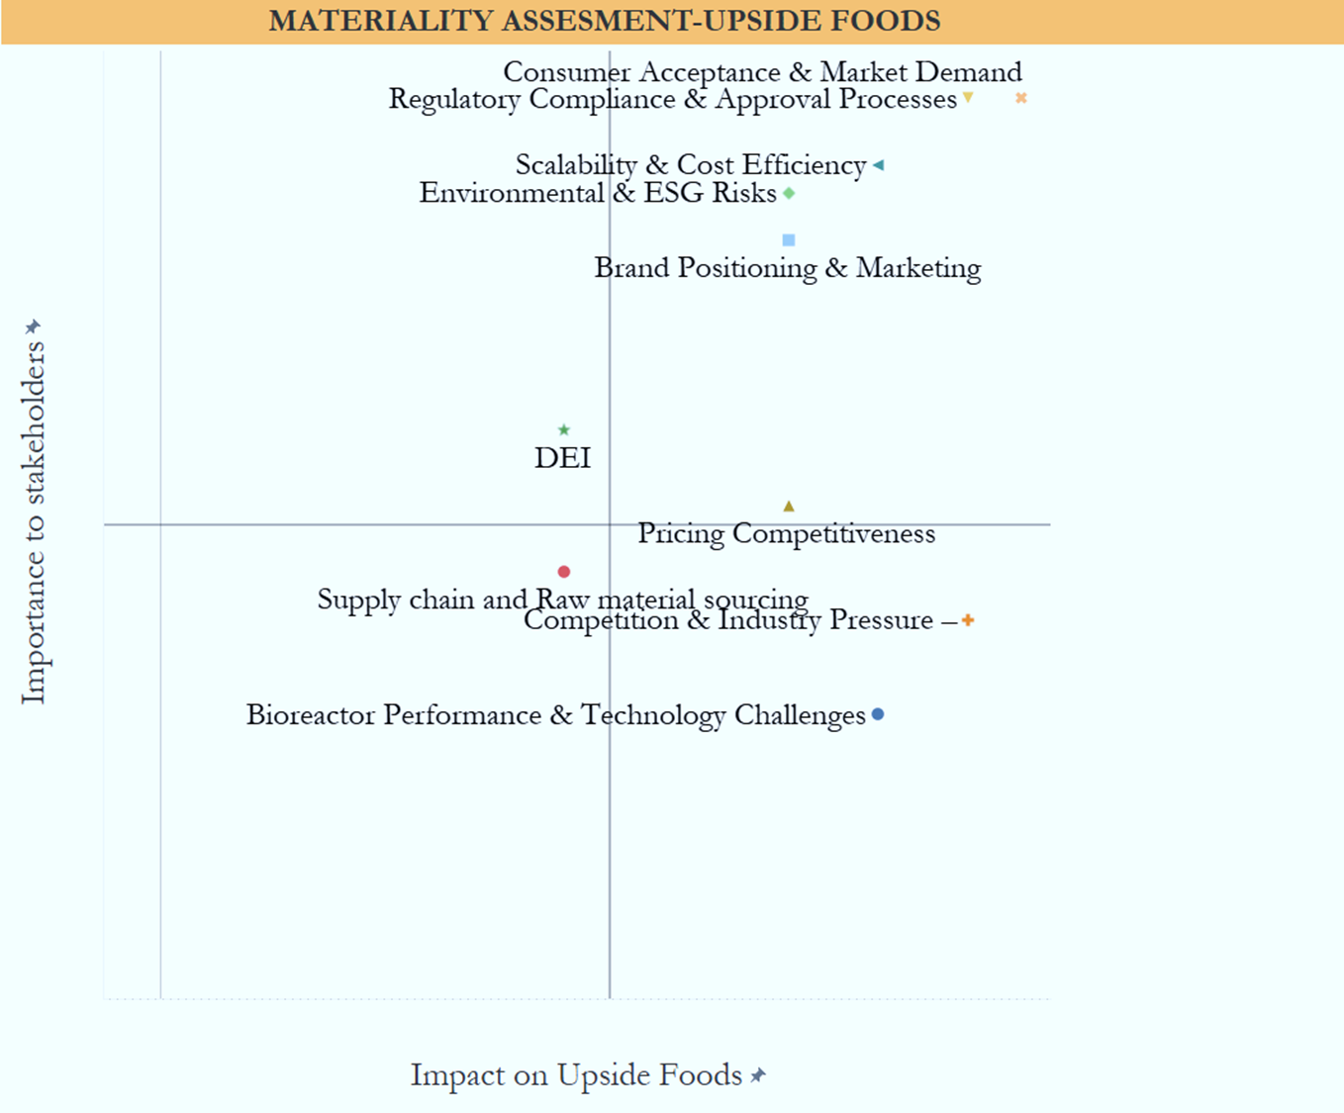

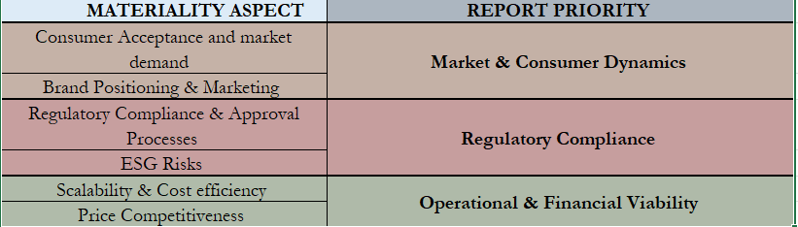

**Data for the REPORT PRIORITY:**

* **Market & Consumer Dynamics**: Upside Foods has proactively introduced antibiotic free cultured meat to consumers through a variety of product launches, including cultured chicken, duck, and meatballs. The company has expanded its presence in high-end restaurants such as Atelier Crenn, Bar Crenn, and Chino Chicano.
* **Regulatory Compliance**: Upside Foods received U.S. FDA and USDA approval in 2023. However, the State of Florida has banned cultured meat due to its impact on the traditional livestock industry and perceived risks to public health.
* **Operational & Financial Viability**: A total of $610.85 million has been received to date, representing one-fifth of all investments in cultured meat.

Our facility operates entirely on renewable energy, achieving a 66% reduction in water consumption compared to conventional beef production. Additionally, since 2016, we have offset four million metric tons of CO₂ through purchases at gas stations.

Production costs have drastically reduced from $18,000 per pound for beef to less than $2,400 per pound by 2017. In addition to operating a facility that produces 50,000 pounds annually using renewable energy, we are planning to establish a 187,000 square-foot facility in Illinois.

With a long-term goal of scaling up production to reduce costs, we are also making significant investments in R&D to further lower the cost of cultured meat to match that of conventional meat. To achieve this, we require top talent FROM biotechnology, food science, and sustainability, whether in our pilot labs or sales teams.

**(Contd..)**

**DELIVERABLES:**

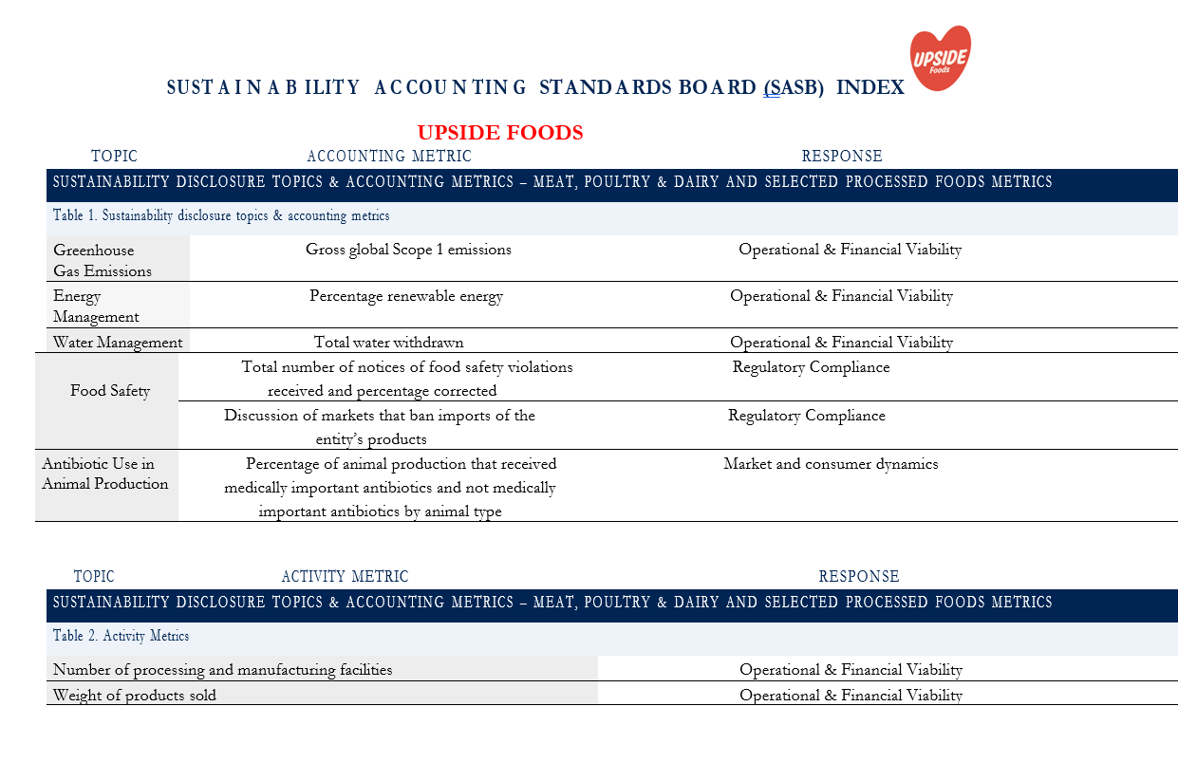

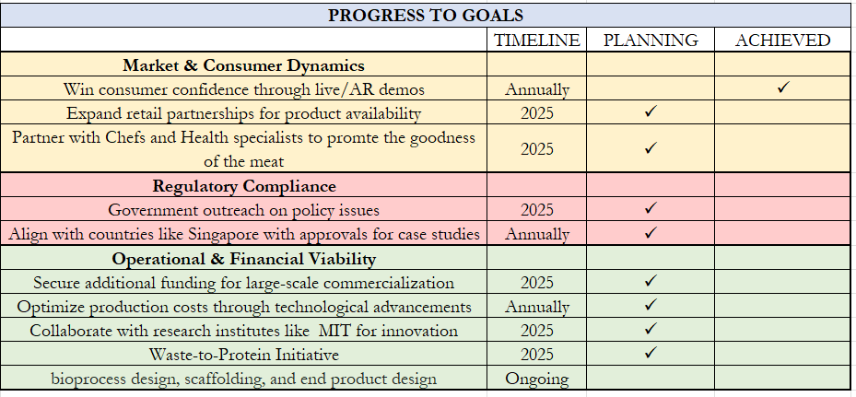

**Budget Allocation for Future growth:**

To scale production to 400,000 lbs/year with 500 new employees (avg salary of 60k-80k), a total investment of $104.75M is required. Allocations are as follows:

* COO - $70M: $50M for facility expansion, AI automation, and production scaling + $20M for operational efficiency and sustainability R&D.
* CFO - $20M: Securing green bonds, optimizing supply chains, and standardizing ESG reporting.
* CHRO - $14.75M. Amount of $6.25M for hiring offset by reallocation, $2.5M for training, and $6M for HR and workforce management.

**Conclusion:**

Building consumer and government confidence in our product is essential. While we proudly serve Michelin-star customers, our goal is to make clean, healthy meat accessible to all. Scaling production through innovation is key to lowering costs and ensuring guilt-free meals. The shift toward alternative proteins is not a passing trend but a permanent transformation.

----------------------------------------------------------------------------------------------------------------------------

**References:**

* **Armanino LLP.** (n.d.). *ESG materiality assessment.* Retrieved February 21, 2025, from <https://www.armanino.com/articles/esg-materiality-assessment>
* **Ditch Carbon.** (n.d.). *Upside Foods carbon footprint.* Retrieved February 21, 2025, from <https://ditchcarbon.com/organizations/upside-foods?utm_source=chatgpt.com>
* **PitchBook.** (n.d.). *Upside Foods company profile.* Retrieved February 21, 2025, from <https://my.pitchbook.com/profile/154278-46/company/profile>
* **PR Newswire.** (2021, November 4). *Upside Foods opens cultivated meat engineering, production, and innovation center (EPIC) as next step in commercialization journey.* Retrieved February 21, 2025, from <https://www.prnewswire.com/news-releases/upside-foods-opens-cultivated-meat-> engineering-production-and-innovation-center-epic-as-next-step-in-commercialization- journey-301416457.html
* **Sustainability Accounting Standards Board (SASB).** (n.d.). *SASB standards download.* Retrieved February 21, 2025, from <https://sasb.ifrs.org/standards/download/results/>
* **Table Debates.** (n.d.). *Insiders reveal major problems at lab-grown meat startup Upside Foods.* Retrieved February 21, 2025, from <https://tabledebates.org/research-library/insiders-reveal-major-problems-lab-grown-> meat-startup-upside-foods
* **Upside Foods.** (n.d.). *Company overview.* Retrieved February 21, 2025, from <https://upsidefoods.com/company>
* **Upside Foods.** (n.d.). *1% for the planet.* Retrieved February 21, 2025, from <https://www.upside.com/blog/1-for-the-planet>
* **Wikipedia contributors.** (n.d.). *Upside Foods.* Wikipedia, The Free Encyclopedia. Retrieved February 21, 2025, from <https://en.wikipedia.org/wiki/Upside_Foods>